Math Attachment Week #1
Journal Entry
Which one does not belong?
Look at the four images in the picture and explain WHY YOU THINK one does not belong. I am not looking for ONE right answer, there are many right answers. I am looking for the one that you think is correct.
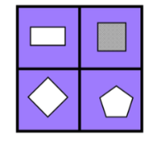

Operations Practice:
1) 305 + 498 = Estimate_________ Actual: _________
2) 4.6 + 6.2 = Estimate___________ Actual: _________
3) 1682 - 500 = Estimate _________ Actual: _________
Problem of the Week:
A. Michael had $1.98 in his wallet, he earned $13.50 raking the lawn. How much money does Michael have all together?

B. If Michael spent $3.25 on a hamburger, $2.50 on french fries, an $1.75 on a drink. How much money does he have left?

